**AUTOMATED TAILGATING DETECTION SYSTEM**

Table of Contents

Abstract 3

Problem statement 3

Literature Survey 3

Tailgating and how it works: 3

Different approach to automated tailgating detection system: 4

i. Computer Vision based approach 4

ii. Simple Motion Detection Video Approach 5

iii. Cameras and mirror method 5

Discussion 5

Challenges in the approach and selection of the concept: 5

Proof of concept 6

Concept description: 6

Figure: SSD Working Principle 6

Block diagram 7

Figure: MobileNet-SSD Architecture Block Diagram 7

Inputs 7

Implementation 7

I. Object Detection 8

Figure: Object Detection Bounding Box 8

II. Object Tracking 8

III. Tailgating tracking 9

Figure: Process Flow Diagram 9

User Experience and software usage 9

Architecture and results 10

Additional Features and Future Works 15

Risks involved 15

Outputs/Results 15

Conclusion 15

References 15

Appendix 1: Detailed Process Flow Diagram for Tailgating detection 17

# Abstract

One of the most common and widespread security breaches affecting organizations today is a social engineering attack known as tailgating (also referred to as piggybacking). Tailgating is a physical security breach in which an unauthorized person follows an authorized individual to enter a typically secured area.

The following document proposes an idea to detect tailgating into a restricted premise using computer vision techniques.

The idea proposed here makes use of an automated system which makes use of a Single Shot Detector (SSD) in order to detect and classify humans in a video segment. The humans segmented in the video are then tracked using a tracking algorithm in order to detect movements and to find out the number of people which enter the restricted area.

This count is then verified with the number of authorised accesses and for a mismatch, the system could be programmed to alert about a possible tailgating incident.

# Problem statement

Given a CCTV camera footage of a secured door entry, detect anyone tailgating using an automated system. The system should segment individuals from the video and detect whether they are tailgating or not.

# Literature Survey

## Tailgating and how it works:

Tailgating is a physical security breach in which an unauthorized person follows an authorized individual to enter a typically secured area.

Tailgating is a fairly simple form of social engineering, a tactic that relies on specific attributes of human decision-making known as cognitive biases. When tailgating, the attacker relies on the other person following common courtesy, either refraining from challenging them or even holding the door. Tailgating can range from simply following a person through doors that have access locks to putting on a disguise to trick people into opening that door. Delivery people, repair men, people struggling with big boxes, people who look busy and important… the list of ways to fool others into opening or holding doors are endless. Being kind to strangers is usually a good thing. But when it comes to the safety and privacy of our workplace we should think twice and be on guard.

## Different approach to automated tailgating detection system:

There can be multiple approaches to detecting tailgating using an automated system such as:

* + 1. Computer Vision based approach: This approach makes use of a image or video input in order to determine any tailgating which would have occurred. The following 2 approaches discuss about different camera placements for detection of any tailgating incident
       1. The camera is positioned directly above the gate with its field of view at the entrance of the gate. The system could try to estimate on the basis of view the number of people that have passed through the gate after which it can then compare this acquired count with the number of card swipes for entry. For a mismatched count the system can be programmed in order to alert the necessary authorities about a possible tailgating incident.
       2. The camera is positioned in a front facing view such that it is directly facing the entry gate. The camera tries to detect humans in the frame and their direction of motion. It then tries to estimate the number of people entering through the entry gate at any time and compares the number of card entries at that time. For a mismatched count the system can be programmed in order to alert the necessary authorities about a possible tailgating incident.
    2. Simple Motion Detection Video Approach: One another method includes the use of simple motion detection video. Motion detection video uses frame-differencing and related methods applied to the output of a video camera.
    3. Cameras and mirror method: U.S. Pat. No. 4,303,851 to Mottier discloses a system using a pair of video cameras focused on two adjacent tracks through a flat mirror and connected to counter circuits. The tracks are perpendicular to a person's direction of travel. Persons passing through this array are detected and counted.

There are various other methods which can be employed for tailgating detection. The method used in the document makes use of the computer vision approach.

# Discussion

## Challenges in the approach and selection of the concept:

As stated above there can be multiple methods of solving the tailgating issue. The method which would be used here would be based on a computer vision approach where the camera is setup above the gate such that the camera faces directly the gate.

The challenges which might occur for the detection could be:

* + 1. Detecting humans with a very high accuracy: Can be overcome by using more than a single camera, i.e., to make use of cameras with different fields of view (say from front and from top) and to combine the results from both cameras for higher accuracy
    2. Identifying humans even if they have some accessory which makes it difficult to identify a human from the camera’s point of view (such as a person wearing a helmet or a cap): Also, could be overcome by using two cameras to detect and segment humans from a video (both cameras having different fields of views)
    3. This approach cannot detect cases where a person carrying another person on their shoulders or in some other way.
    4. Detecting tailgating with high speed and accuracy (speed depends on the hardware used to run the detection system and hence the system needs to be a lightweight process that doesn’t require much computational power in order to just require the camera resources to run the system)

# Proof of concept

## Concept description:

The following document proposes the idea for tailgating detection using a Single Shot Detector (SSD).

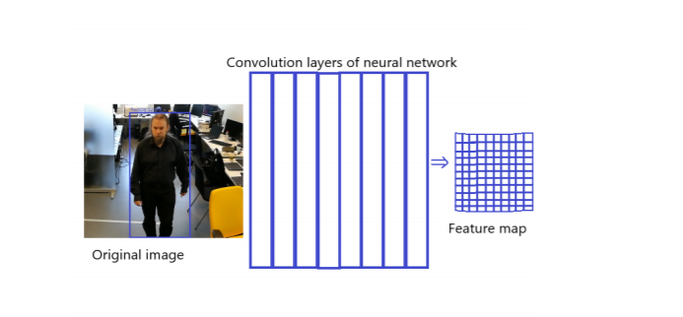SSDs are algorithms that are used in object detection and classification on images. The name comes from the idea of only running the convolutional network once on the input image in order to form a feature map. Then a small convolutional kernel is run on the feature map to form the bounding boxes for the recognized objects as shown in the following figure

### Figure: SSD Working Principle

After going through a certain of convolutions for feature extraction, we obtain **a feature layer of size**m**×**n**with**p**channels. For each location, we got**k**bounding boxes.**These ‘k’ bounding boxes have different sizes and aspect ratios. The concept is, maybe a vertical rectangle is more fit for human, and a horizontal rectangle is more fit for car. **For each of the bounding box, we will compute ‘**c’**class scores and 4 offsets relative to the original default bounding box shape.** Thus, we got {**(**c**+4)**kmn}**outputs.**

## Block diagram

### Figure: MobileNet-SSD Architecture Block Diagram

## Inputs

The inputs necessary for the automated tailgating detection system are:

1. A video feed for detecting humans and any tailgating incident.
2. The entry card swipe records for detecting number of authorised accesses at any particular time

## Implementation

In order to build the people counting application which would be used to calculate the number of people entering a gate we would require some python libraries such as:

1. NumPy
2. OpenCV
3. dlib
4. imutils

The complete process can be divided into three phases namely:

1. 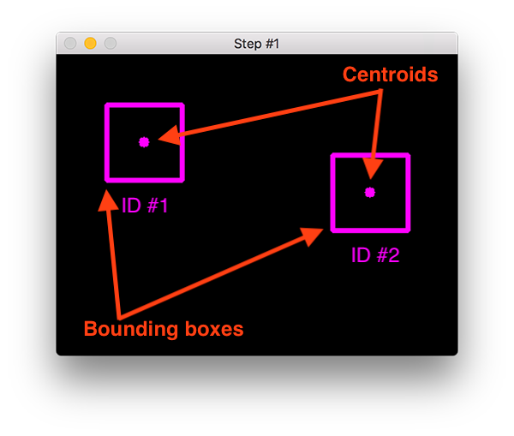Object Detection: Object detection, in computer vision context, is defined as an ability to find specific objects of interest in an image.

This phase includes the usage of a Single Shot Detector such as MobileNet SSD which would detect if new objects have entered the view. By using SSD, we only need to**take one single shot to detect multiple objects within the image.**  
For each new object detected we create an object tracker with the new bounding box coordinates for which then we find the centroid.

### Figure: Object Detection Bounding Box

1. Object Tracking: Object tracking is the process of taking an initial set of object detections such as bounding box coordinates, creating a unique id for each detection and then tracking each of the unique objects detected using the centroid associated with each of the objects.  
   The object tracking algorithm relies on the Euclidean distance between existing object centroids and new object centroids captured in subsequent frames in the video. The primary assumption of the centroid tracking algorithm is that a given object will potentially move in between subsequent frames, but the distance between the centroids for frames F(t) and F(t+1) (for some arbitrary ‘t’) will be smaller than all other distances between objects. Therefore, if we choose to associate centroids with minimum distances between subsequent frames, we can build our object tracker.
2. Tailgating tracking:

In this phase the number of humans passing through the gate which are detected in the frame is compared with the number of authorised entries and for a mismatch the system would raise an alert to the necessary authorities about the possible tailgating.

The number of authorised entries can be found by the number of card entries at the entry gate.

The complete process flow diagram is shown below:

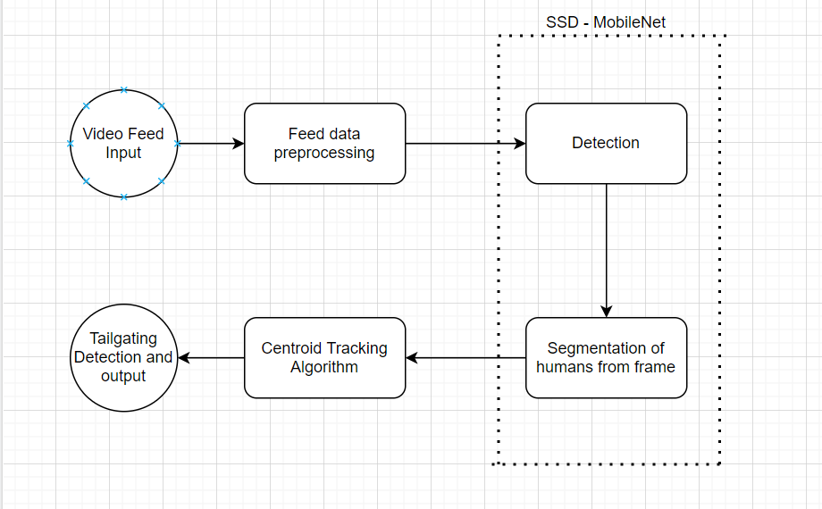

### Figure: Process Flow Diagram

## User Experience and software usage

Our software would be easily configurable by anybody, as we will be providing a simple interface to the guard/admin who by using this interface would be able to draw a virtual line on the live camera feed.

This LINE’s coordinates will be sent to the code-behind i.e., backend of the app where the live feed is being processed, and the line will be used as a line of reference across which tailgating can be detected.

The customizable line can be used in order to place the camera for tailgating detection nearly ANYWHERE.

The front end (of the app) can be configured to receive employee card swipe data in the form of JSON on a specified port so that this software can integrate with any security system.

## Architecture and results

* + Setup description:
    - Over the head camera

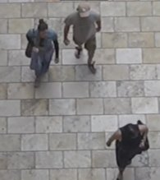 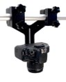

* + - Virtual gate + virtual line

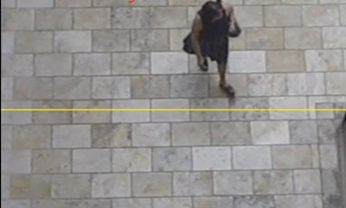

* + - Card reader:

0 => No card read

1 => Card read



* + Inputs:
    - Video stream for object detection
      1. Made use of own set of videos to test and validate the detection
      2. Used 5 sets of video ; 4 generated by own camera

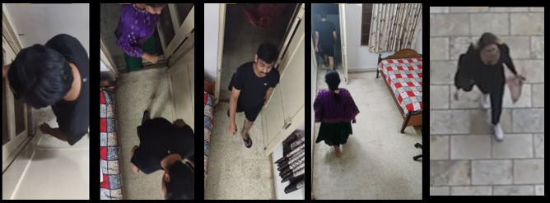

* + - Card Swipe inputs

Represented using CSV file:

* + - 1. 0 – No card swipe
      2. 1 – Card Swipe

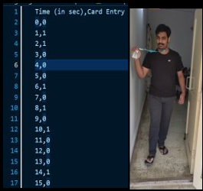

* + Tailgating Detection process
    - Object Detection

Object Detection

(Detected Object shown with green point)

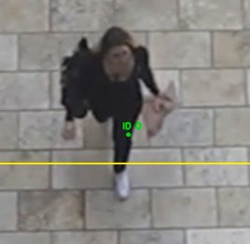

* + - Object Tracking

Object Tracking

(Tracked using direction of movement and indicated below (Count))

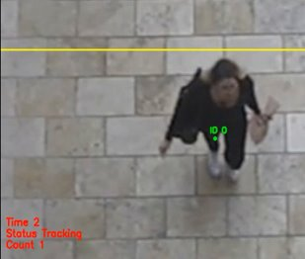

* + - Alert on Tailgating

Alert on Tailgating

(Number of tailgates alerted on video too )

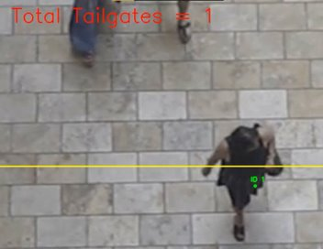

* + Outputs:
    - Video warning

Video warning

Displayed on top of video

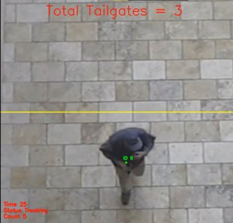

* + - Audio based warning

Beep Sound generated for tailgating detection

* + - Log file

Log files showing

* + - 1. total count of entries
      2. card entries per sec

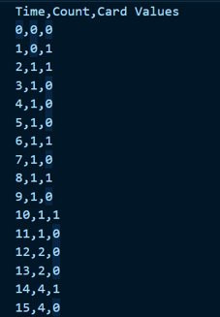

## Additional Features and Future Works

Facial Recognition: We can also add facial recognition as a feature if the employee database consists of pictures of each employee and these pictures can be provided to us in order to not only detect the person who is tailgating but also release the picture of the intruder detected to the necessary authorities and also to verify (if possible) whether the intruder is someone in the database or not.

## Risks involved

One small drawback is related to the underlying assumptions of the tracking algorithm itself — centroids must lie close together between subsequent frames. This assumption typically holds but keeping in mind we are representing our 3D world with 2D frames where it might happen that an object overlaps with another one giving rise to object ID switching. If two or more objects overlap each other to the point where their centroids intersect and instead have the minimum distance to the other respective object, the algorithm may (unknowingly) swap the object ID.

## Outputs/Results

The required output/result would be a successful tailgating detection system which could detect quickly and accurately a tailgating incident without requiring very high computational resources.

# Conclusion

Existing solutions to tailgating were studied and the proposed solution in this document would more likely be able to solve the issue efficiently.

# References

* <https://www.theseus.fi/bitstream/handle/10024/171489/Tuomola_Tommi.pdf?sequence=2&isAllowed=y>
* <https://www.scitepress.org/papers/2009/16657/16657.pdf>
* <https://arxiv.org/abs/1512.02325>
* <https://towardsdatascience.com/review-ssd-single-shot-detector-object-detection-851a94607d11>

# Appendix 1: Detailed Process Flow Diagram for Tailgating detection

